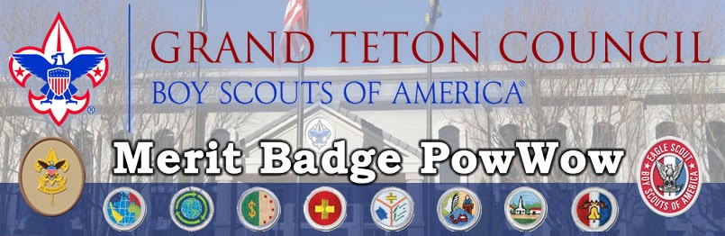

# January 20th and February 10th 2024 Idaho Falls Scout Service Center

3910 S Yellowstone Hwy, Idaho Falls, ID 83402

7:30 am until 1:00 pm

Register December 1st – January 10th [www.tetonscouts.org](http://www.tetonscouts.org/)

You can take 4 Merit Badge classes. Snacks provided

When you register, select 6 classes in the order of your preference.

You will get the first four available. Class sizes will be limited to 10 people.

Bring a pen, MB worksheet, MB blue card signed by scout leader, and registration.

# $25 Registration - $35 After Dec 20th

Registration opens Dec 1st – Late Registration allowed until Jan 10.

|  |  |  |
| --- | --- | --- |
| Cit. in the Nation | Communication | Energy |
| Cit. in the World | Sustainability | American Heritage |
| Cit. in the Community | Railroading | Engineering |
| Fire Safety | Disability Awareness | Electricity |
| Pets | Genealogy TBD | Coin Collecting TBD |

## For Information: [www.tetonscouts.org](http://www.tetonscouts.org/)

*Curtis Roth at* [*curtisroth52@gmail.com*](mailto:curtisroth52@gmail.com) *208-881-4959*